Title Goes Up Here

1. Generate Duplicate List
   1. Use list provided by Evelyn, generated using RE merge tools
2. Pre-Processing
   1. Identifying “difficult” merges
      1. Put all IDs into new query
      2. Save query into Merges folder
      3. Run “Duplicate Merge – ID Manual Changes” export
      4. In export, sort pairs by Const ID (see formula below)
         1. Split Const ID into two columns using – as delimiter
         2. Sort first on Sort Name column, second on Const ID prefix, third on Const ID suffix
      5. Identify problems (mark in yellow for fixing later):
         1. Spouses
            1. Different
            2. Primary has no spouse, secondary does
            3. Primary has non-Const spouse, secondary has Const spouse
         2. Conflicting RMs
         3. Conflicting Master/Non-Master
   2. IOM Address Update
      * 1. Copy secondary record Const IDs to new sheet (see formula below)
        2. Open “Mergician Address Update Query” and add second records as Const ID one of… and save query
        3. Export this new “Mergician Address Update Query”
        4. Sort by “Sort by” column
        5. Replace Const ID with primary’s Const ID
        6. Clean up invalid/useless addresses (make sure to correctly format zip codes)
        7. Delete Sort By column
        8. Open IOM and run export through “Mergician Address Import”

c. Preparing Merge Document

1. Use correctly sorted list (last name, ID prefix, ID suffix), with primaries first
2. Use macro to number merge pairs (see below) so that primary and secondary records have the same merge pair ID
3. Final manual check to make sure all merge pairs are correct and in correct order.
4. Running Mergician
   1. In RE go to plug-ins, The Mergician
   2. Select merge file in top box
   3. Settings:
      1. Merge File Format—for these instructions, duplicates are on separate rows
      2. Options:
         1. Merge:

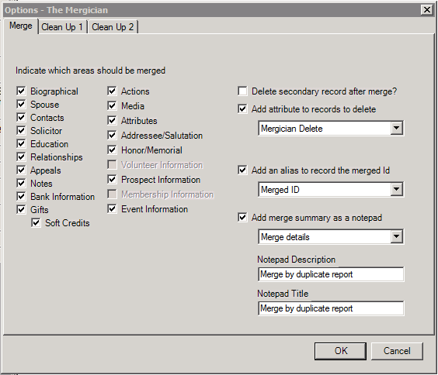

* + - 1. Clean Up 1:

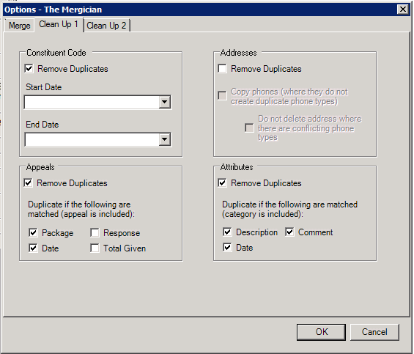

* + - 1. Clean Up 2:

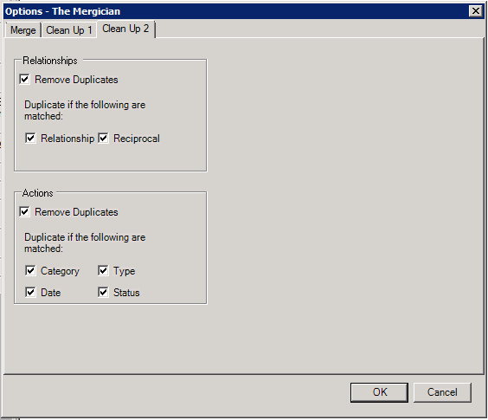

* 1. Set mapping so that Mergician knows which is the constituent ID and which is the merge ID
  2. Create new control report file
  3. Check merged records query box
  4. Start!

1. Post-Processing
   1. Look at flagged entries from section II.a.v
      1. Update addressee/salutation information for records with merged spouses
      2. Update RM information
      3. Update Master/Non-Master relationships

Pulling out odd-numbered rows:

=OFFSET(<worksheet>!A1,(ROW()-1)*1,0)

Separating beginnings or ends of cells:

=LEFT(A2,FIND("-",A2&"-")-1)

=RIGHT(A2,LEN(A2)-FIND("-",A2))

Numbering Pairs:

Sub PairNumbering2()

Do Until IsEmpty(ActiveCell.Offset(0, 1).Value) = True

ActiveCell.Value = "=INT((ROW()-ROW($A$1))/2)+1"

ActiveCell.Offset(1, 0).Select

Loop

ActiveCell.EntireColumn.Copy

ActiveCell.EntireColumn.PasteSpecial xlPasteValues

End Sub

Prepping for address import:

Sub MergicianExportSorting()

'Select Col B, insert two blank rows

Range("B:B").Select

Selection.Insert (xlShiftToRight)

Selection.Insert (xlShiftToRight)

'Copy Const IDs to first blank row

Range("A:A").Copy

Range("B:B").PasteSpecial

'Convert text to columns, using - as delimiter

Range("B:B").TextToColumns Destination:=Range("B:B"), DataType:=xlDelimited, TextQualifier:=xlDoubleQuote, ConsecutiveDelimiter:=True, Other:=True, OtherChar:="-"

'Name new columns

Range("B1").Value = "ID_Prefix"

Range("C1").Value = "ID_Suffix"

'Sort by Sort Name, Prefix, then Suffix

Range("A:AF").Sort key1:=Range("E:E"), order1:=xlAscending, key1:=Range("B:B"), order1:=xlAscending, key1:=Range("C:C"), order1:=xlAscending, Header:=xlYes

Range("B:C").Delete

End Sub